**Wireframe Document**

**PRESCRIPTION LABEL READING**

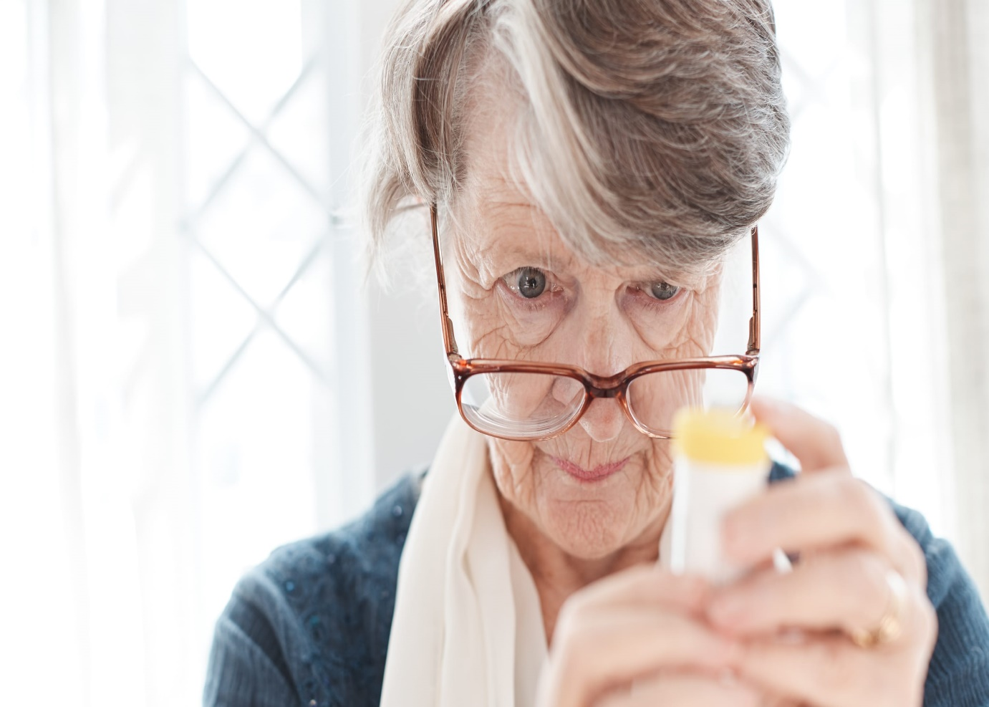

**Revision Number - 1.0**

**Last Date of Revision – 08-07-2022**

**SRIPHANI**

# Document Control

|  |  |  |  |  |
| --- | --- | --- | --- | --- |
| **Date** |  | **Version** | **Description** | **Author** |
| 08-07-2022 | 1.0 |  | Wireframe Documentation | Aniruddha |
|  |  |  |  |  |
|  |  |  |  |  |
|  |  |  |  |  |

**We Performed PADDLEOCR technique and gTTS.**

**Refer the notebook.**